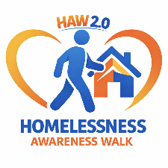
HAW2.0 — HOMELESSNESS AWARENESS WALK 2026
REGISTRATION FORM
Saturday, September 26, 2026 • Manistee, Michigan Hosted by Safe Harbor & ECHO His Love
PARTICIPANT INFORMATION
Full Name: ________________________________________________
Address: _________________________________________________
City/State/ZIP: ___________________________________________
Phone: ______________________ Email: ____________________________________
Age: ______ ☐ Minor (under 18 — parent/guardian signature required)
EMERGENCY CONTACT
Name: ________________________________________________
Relationship: __________________________ Phone: ________________________________
PARTICIPATION TYPE
☐ Walker ☐ Volunteer ☐ Both
Team / Group Name (optional): _______________________________________
DONATION ADD-ONS (Optional)
One-Time Donation Amount: $________________________
I am walking in honor/memory of:
LIABILITY WAIVER & PHOTO RELEASE
Please read and sign below.
I understand that participating in the Homelessness Awareness Walk 2026 involves physical activity and outdoor conditions. By signing, I acknowledge that I am voluntarily participating and assume all risks associated with walking or volunteering at this event.
I release Safe Harbor, ECHO His Love, event organizers, volunteers, and partners from any liability for injury, illness, or damages that may occur as a result of my participation.
I also grant permission for event photos or videos that include me to be used for outreach, awareness, and promotional purposes.
Participant Signature: ____________________________________ Date: _____________
Parent/Guardian Signature (if minor): ________________________ Date: _____________
CONTACT & SUBMISSION
Safe Harbor of Manistee County ECHO His Love — Family Services Division Return completed forms to: Jeff Carter Questions? Contact: jeffc@echohislove.org

