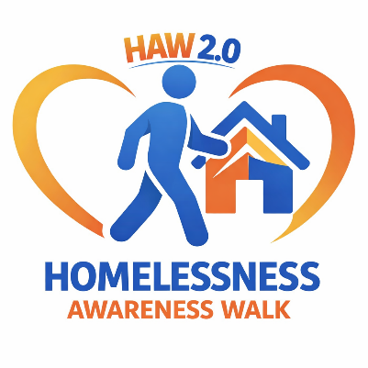
Homelessness Awareness Walk

September 2026

Event Itinerary
- 9:00 a.m. - 9:45 a.m. Agency setup and participant arrival. Participating agencies arrive and set up their information tables. Walk participants begin arriving and gathering at the starting location.
- 9:45 a.m. - 10:00 a.m. Welcome and event instructions. Organizers welcome attendees, share the purpose of the event, review the walk route, and provide basic participation instructions.
- 10:00 a.m. - 11:00 a.m. Homelessness Awareness Walk. The walk begins at 525 Michael Street and proceeds to the Lions Pavilion.
- 11:00 a.m. - 11:30 a.m. Speakers and community gathering. Attendees gather at the Lions Pavilion to hear from speakers and learn more about homelessness awareness and available community resources.
- 11:30 a.m. - 12:15 p.m. Agency information sharing and meal service. Participants visit agency tables, gather information, and connect with local services. Free meals are provided for walkers and participating agencies.
- 12:15 p.m. - 12:30 p.m. Closing and cleanup. Organizers thank participants, agencies begin packing up materials, and the event concludes.

Event Procedures
- General Procedures: Participation is free and open to the public. Participants may carry signs related to homelessness. All event activities should remain respectful and focused on awareness, education, and community support.
- Agency Procedures: Agencies may set up an information area at the event. Each agency is responsible for bringing its own table and materials. Agencies may offer raffles, but no items may be sold.
- Food Procedures: Free meals will be available for walkers and participating agencies. Meals are not available for the general public unless they are registered walkers or agency participants.
- Closing Procedures: Agencies should remove their materials at the end of the event. Organizers should confirm the area is clean and all event materials have been collected before leaving.

